# Underwriting Workbench

|  |  |  |  |
| --- | --- | --- | --- |
|  | **Submission System** | **Underwriting Workbench** | **Policy Administration System (PAS)** |
| **Purpose** | Handles the **pre-bind phase** of the insurance lifecycle. | Provides a centralized platform for underwriters to assess risk and make decisions. | Manages the **entire lifecycle of an insurance policy** after it is bound. |
| **Definition** | Designed to **evaluate and process incoming insurance applications** before a policy is issued. Optimized for **speed, collaboration, and decision-making** during underwriting. | Enables underwriters to **review submissions, apply rules, assess risk, and make decisions**. Integrates with the Submission System for intake and passes approved cases to PAS for issuance. | The **operational core** of most insurance companies. Stores and manages all policy-related data and automates back-office functions such as billing, endorsements, and compliance. |
| **Used by** | Underwriters, brokers, and MGAs (Managing General Agents). | Underwriters | Insurance carriers, operations teams, customer service, and compliance. |
| **Key Functions** | • Intake of new insurance applications or submissions • Risk triage and appetite matching • Collaboration between brokers and underwriters • Application of underwriting rules • Tracking decisions, referrals, and approvals | • Risk scoring and rule application • Collaboration tools for referrals and approvals • Integration with third-party data sources (e.g., credit, claims history) • Decision support (accept, decline, modify terms) | • Policy quoting and issuance • Billing and payment processing • Endorsements, renewals, and cancellations • Claims management • Regulatory compliance and reporting |

**🧩 Does Guidewire PolicyCenter Have Underwriting Capabilities?**

**Yes, it does — but with limitations.**

Guidewire PolicyCenter includes **basic underwriting functionality**, such as:

* **Submission intake and processing**
* **Risk assessment rules**
* **Underwriting authority checks**
* **Referral workflows**
* **Integration with rating engines**

However, these capabilities are **not always sufficient** for complex underwriting scenarios, especially in **commercial lines** or **specialty insurance**, where underwriters need:

* Deep risk analysis
* Collaboration across teams
* Document management
* Integration with external data sources (e.g., risk scores, geospatial data)
* Advanced decision support tools

**🧠 Why Do We Need an Underwriting Workbench?**

An **Underwriting Workbench** is a **specialized tool** designed to support **complex, high-touch underwriting** processes. It complements PolicyCenter by offering:

**✅ Advanced Capabilities:**

* **360° view of the risk**: Pulls data from multiple systems (CRM, claims, inspections, etc.)
* **Decision support**: AI/ML-based risk scoring, predictive analytics
* **Collaboration tools**: Notes, approvals, shared views
* **Workflow orchestration**: Tailored to underwriter roles and product lines
* **Audit trails and compliance**: For regulatory and internal governance

**✅ Flexibility:**

* Can be customized for different lines of business
* Supports integration with external data providers (e.g., Dun & Bradstreet, ISO)

**✅ Efficiency:**

* Reduces manual work
* Speeds up decision-making
* Improves consistency and transparency

**🔄 How It Works with PolicyCenter**

Think of **PolicyCenter** as the **transactional system** and the **Underwriting Workbench** as the **decision support layer**. They often integrate like this:

* Submission enters PolicyCenter
* Referral triggers Underwriting Workbench
* Underwriter reviews, scores, and decides
* Decision flows back to PolicyCenter for binding or further action

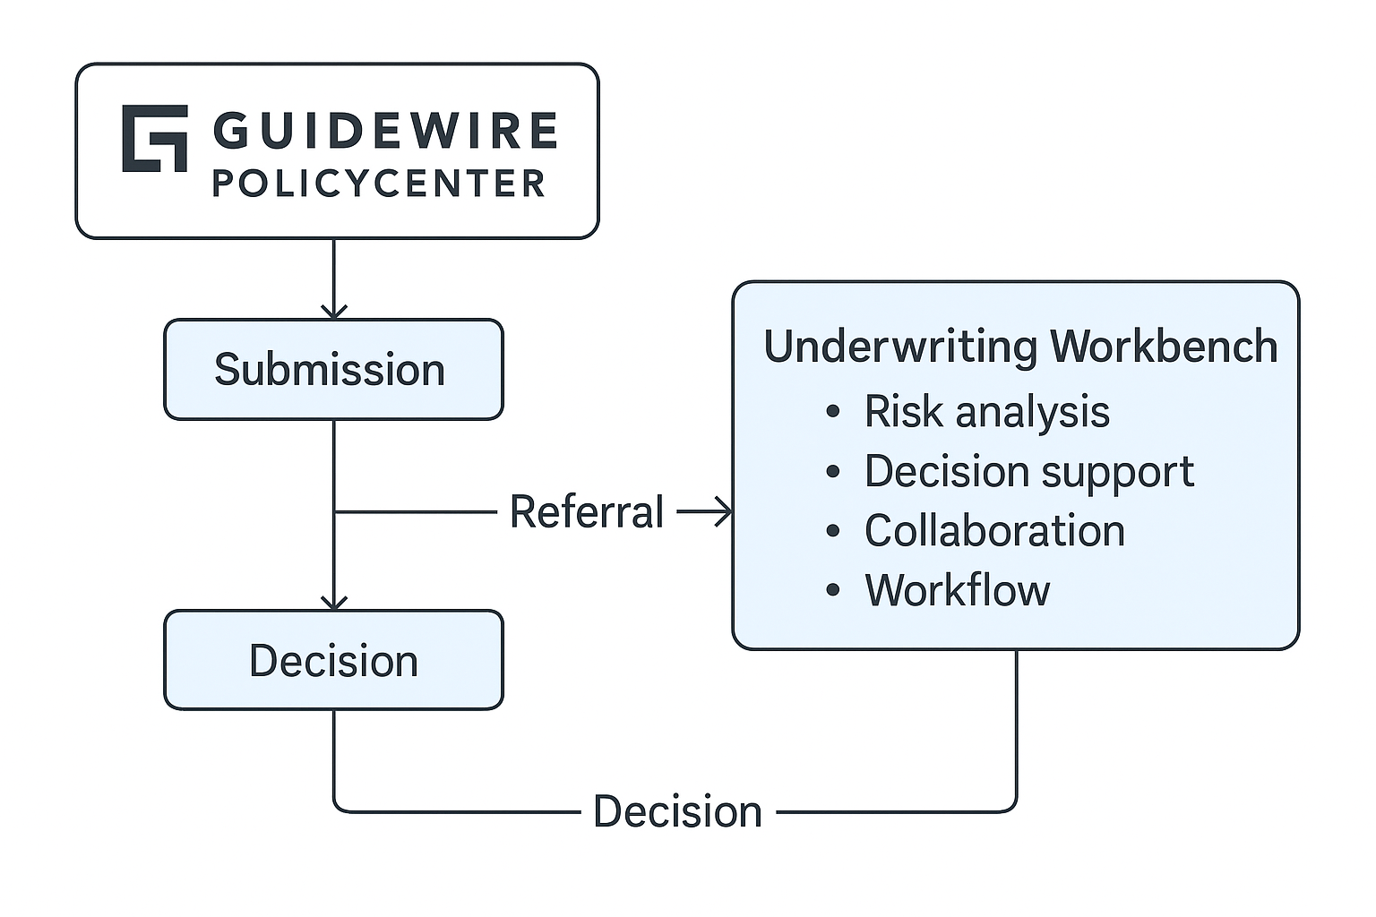

**PolicyCenter** handles submissions and basic underwriting.

When a case requires deeper analysis, it triggers a **referral** to the Underwriting Workbench.

The **Underwriting Workbench** provides:

* Risk analysis
* Decision support
* Collaboration tools
* Workflow orchestration

The decision then flows back to PolicyCenter for binding or further processing.

# Limitation of Guidewire PolicyCenter and Policy Administration Systems (PAS)

**Guidewire PolicyCenter and PAS Submission Structure**

Most **Policy Administration Systems (PAS)**, including **Guidewire PolicyCenter**, are designed around the concept of a **submission** representing a single **policy transaction**. This usually means:

* **One policy per submission**
* That policy belongs to **one line of business (LOB)**
* Within that LOB, you can add **multiple coverages** (e.g., liability, property, endorsements)

**Can You Add Multiple Products or LOBs in One Submission?**

**By default, no.**  
PolicyCenter does **not allow multiple LOBs or products in a single submission** because:

* Each LOB often has **different rating engines, rules, forms, and workflows**
* Regulatory and compliance requirements differ by LOB
* Complexity in billing and claims handling increases significantly

**Why This Limitation Exists**

* **Data Model Design:** PolicyCenter’s data model ties a submission to a single policy term and LOB.
* **Operational Simplicity:** Keeps underwriting, rating, and issuance processes streamlined.
* **Integration Constraints:** External systems (billing, claims) expect one policy per transaction.

**Workarounds**

* **Multi-Policy Quoting:** Some carriers implement custom solutions or use Guidewire’s **Quote & Apply** or **Digital Portals** to allow customers to quote multiple products together, but these still create separate submissions behind the scenes.
* **Custom Extensions:** Advanced carriers sometimes build custom workflows to mimic multi-product submissions, but this adds complexity and cost.
* Implementing an **Underwriting Workbench (UWB)** can be a very effective solution — not just a workaround — for the limitations mentioned in PolicyCenter or other PAS systems.

Here’s why and how:

**✅ Why UWB Helps**

1. **PolicyCenter Limitation:**
   * A single submission typically supports **one policy and one LOB**.
   * Complex commercial accounts often require **multiple products or LOBs** under one customer interaction.

**Impact:** Without UWB, underwriters must create multiple submissions manually, which is inefficient and error prone.

1. **Underwriting Complexity:**
   * PAS systems are transactional and optimized for straight-through processing.
   * They lack advanced tools for **risk analysis, collaboration, and multi-policy orchestration**.

**✅ How UWB Solves This**

* **Account-Level View:**   
  UWB can aggregate multiple submissions (from different LOBs) into a **single underwriting case**. This gives underwriters a **360° view of the customer and risk**.
* **Multi-Product Handling:**  
  Instead of forcing PAS to handle multiple LOBs in one submission, UWB acts as an **orchestration layer**:
  + Create separate submissions in PolicyCenter for each LOB.
  + Links them together on the workbench for unified decision-making.
* **Advanced Decision Support:**
  + Integrates external data (credit scores, geospatial risk, loss history).
  + Provides AI-driven risk scoring and recommendations.
* **Collaboration & Workflow:**
  + Enables multiple underwriters to work on different LOBs simultaneously.
  + Tracks approvals, notes, and compliance across all related policies.

**✅ Benefits**

* **Operational Efficiency:** Reduces manual duplication of submissions.
* **Improved Risk Selection:** Better decisions with holistic data.
* **Customer Experience:** Faster turnaround for multi-product quotes.
* **Scalability:** Supports complex commercial accounts without heavy PAS customization.

**Dashboard View**

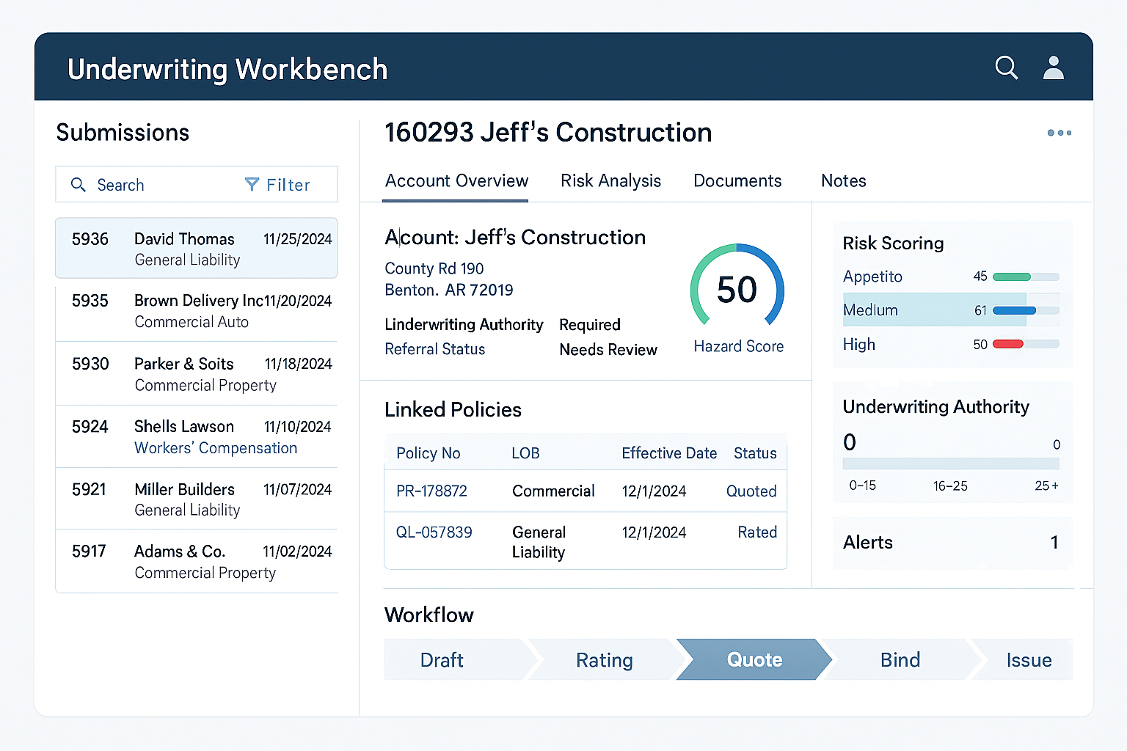

Here’s a **model screen-print for the Dashboard View** of an Underwriting Workbench:

**What It Shows**

* **Submissions Queue (Left):** Multiple active submissions across LOBs.
* **Account Overview (Center):** Account details, hazard score, underwriting authority, referral status.
* **Risk Scoring (Right):** Appetite match, medium/high risk indicators.
* **Workflow Panel (Bottom):** Visual stages (Draft → Rating → Referral).
* **Alerts:** High wind score, referral required.

**Risk Analysis Tab**

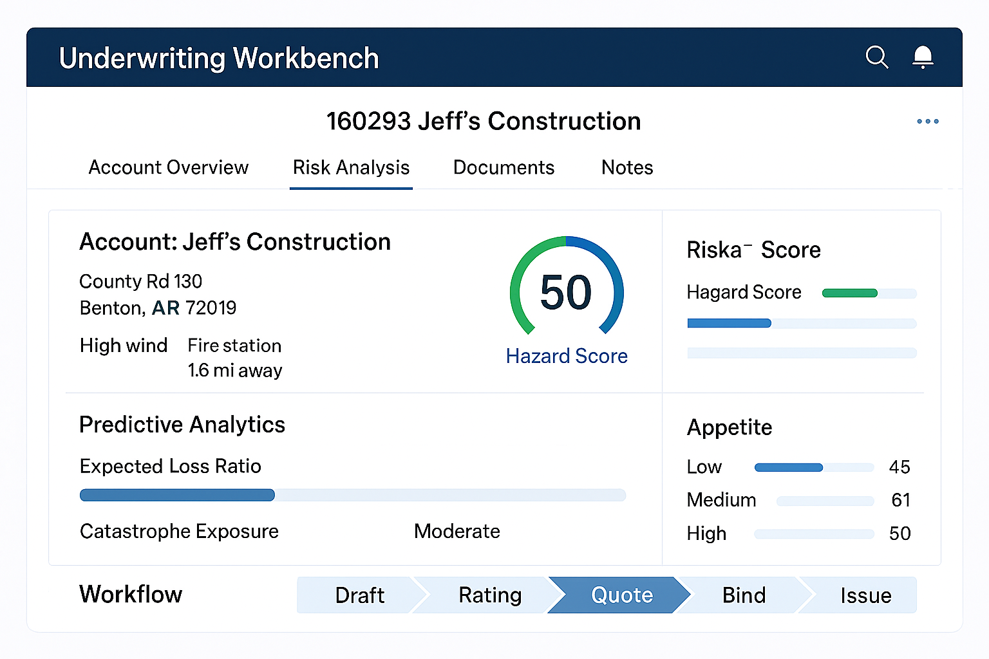

Here’s a **mock-up for the Risk Analysis tab** of the Underwriting Workbench:

**Key Elements Displayed**

* **Account Details:** Location, hazard indicators (e.g., high wind, proximity to fire station).
* **Hazard Score Widget:** Visual gauge showing risk level.
* **Predictive Analytics:** Expected loss ratio and catastrophe exposure.
* **Appetite Matching:** Low/Medium/High fit indicators.
* **Workflow Bar:** Draft → Rating → Quote → Bind → Issue.

**Submission Details Screen (Left Panel) & Integrated Data Widgets (Right Panel)**

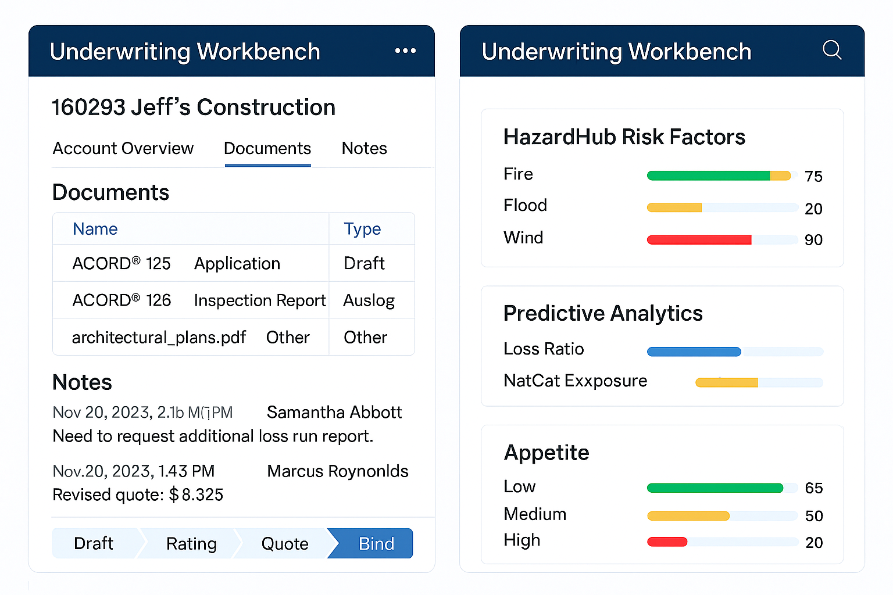

Here’s the **composite mock-up** combining:

**Left Panel – Submission Details Screen**

* **Tabs:** Documents and Notes.
* **Documents:** ACORD® 125 (Application), ACORD® 126 (Inspection Report), architectural plans.
* **Notes:** Underwriter comments and broker communication.
* **Workflow Bar:** Draft → Rating → Quote → Bind.

**Right Panel – Integrated Data Widgets**

* **HazardHub Risk Factors:** Fire (75), Flood (20), Wind (90).
* **Predictive Analytics:** Loss Ratio and NatCat Exposure indicators.
* **Appetite Matching:** Low (65), Medium (50), High (20).

**E2E Underwriting Workbench Workflow**

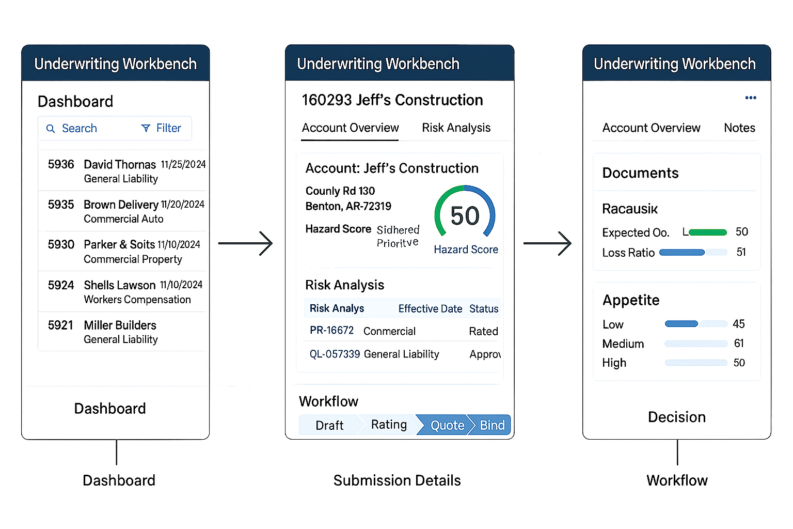

Here’s the **end-to-end Underwriting Workbench screen flow diagram**:

**Flow Overview**

1. **Dashboard**
   * Displays submission queue with LOBs and dates.
   * Search and filter options for underwriters.
2. **Submission Details**
   * Account overview with hazard score.
   * Risk Analysis tab showing linked policies and predictive indicators.
   * Workflow bar: Draft → Rating → Quote → Bind.
3. **Decision Screen**
   * Documents tab with ACORD forms and inspection reports.
   * Appetite matching and predictive analytics widgets.
   * Notes for collaboration and broker communication.